3001CEM Advanced Computer Architecture

Coursework

Alexander Moses

**Table of Contents**

**1. Introduction**

Page 2: Introduction

**2. Section A – Microprocessor Comparison**

[Page 3: CPU](#_CPU_(340_words))

[Page 3: Performance](#_Performance_(337_words))

[Page 4: Cache](#_Cache_(168_words))

Page 4: Power and Heat

[Page 5: GPU](#_GPU_(131_words))

[Page 5: Memory](#_Memory_(103_words))

Page 5: Instruction Set Architecture

[Page 6: CPU Architecture](#_CPU_Architecture_(459)

Page 10: Conclusion

**3. Section A – Algorithm**

Page 11: Algorithm

**4. Section B – Parallel Processing**

[Page 13: SMP](#_SMP_(Symmetric_Multiprocessing))

Page 13: Cluster

Page 14: CC-NUMA

**5. References**

Page 16: References

# **Introduction**

# **Section A – Microprocessor Comparison**

The first section of the assignment is split into two, the first is the comparison of two microprocessors, from two different classes, from two different manufacturers. The first CPU is the I7-8700K made by Intel used for desktops, used by gamers and PC enthusiasts. The second CPU is the Ryzen 7 2700U made by AMD used for notebooks, used for high-end gaming and workstation notebooks. I have chosen these two as the I7-8700K is the new high-end consumer-grade desktop processor, and the Ryzen 7 2700U is the new high-end consumer-grade notebook processor, allowing me to truly compare the two classes with them both being the top of the line in their class.

# **Section A – Algorithm**

The second part of section A is to create an algorithm in the Assembly programming language using an instruction set from one of the two processors. With both processors sharing the same base instruction set, it’s been created in x86-64. It contains two examples of the algorithm, one created by a person and the other being it converted from C++ using the x86-64 assembly converter.

# **Section B – Parallel Processing**

The final section of the assignment is to conduct research on symmetric multiprocessor (SMP), Cluster, and cache-coherent Non-Uniform Memory Access (CC-NUMA), descriptions of all and a comparison between them.

# **Section A – Microprocessor Comparison**

The I7 8700k is Intel’s 8th generation consumer grade I7 for desktop computers built on the Coffee Lake architecture, it was released on the 6th October 2017 at $370 (Intel, 2017) (£273.10). The Ryzen 7 2700U is AMD’s high-end Ryzen generation processor for notebooks build on the Zen architecture, it was released on the 26th October 2017 at $329 (AMD, 2017) (£243.10).

# **CPU**

|  |  |  |  |  |
| --- | --- | --- | --- | --- |
| Processor | Cores | Threads | Base Clock Speed | Turbo Clock Speed |
| I7 8700K | 6 | 12 | 3.7Ghz | 4.3Ghz - 4.7Ghz |
| Ryzen 7 2700U | 4 | 8 | 2.2Ghz | 3.8Ghz |

CPU Specs (Wikichip, 2017)

Intel’s I7-8700K features a hex-core design compared to AMD’s Ryzen 7 2700U’s Quad-core, both fashioning some form of threading technology (Intel’s being Hyperthreading, AMD’s being HyperTransport) thus resulting in the I7 having 12 threads and the Ryzen having 8 threads. This allows the operating system to identify each physical core as two virtual cores and allows them to do two independent tasks if one task requires resources that aren’t available then the other task can continue. All of this allows the I7 to be able to perform more operations at the same time but it also results in a much higher power usage and a hotter running temperature.

The I7s base clock speed is 3.7Ghz with a turbo clock speed varying from 4.3Ghz to 4.7Ghz (decreasing from 4.7Ghz by 0.1Ghz for each core i.e 1st core 4.7Ghz, 2nd core 4.6Ghz), whereas the Ryzen has a base clock speed is 2.2 GHz with a turbo clock speed of 3.8Ghz across all cores. This allows the I7 to perform more operations per second allowing for much faster performance but again it also results in a much higher power usage and a hotter running temperature.

Overclocking specs (Wikichip, 2017)

|  |  |  |
| --- | --- | --- |
| % of Chips | Frequency | VCore |
| 100% | 4.9Ghz | 1.387V |
| Top 81% | 5.0Ghz | 1.400V |
| Top 58% | 5.1Ghz | 1.412V |
| Top 30% | 5.2Ghz | 1.425V |
| Top 6% | 5.3Ghz | 1.437V |

In Addition, the I7 being a K variant desktop processor it has the capability of overclocking, allowing it to increase the base clock speed to a higher value with the exchange of more power usage (compared to the 1.356 core voltage at stock speed) and generating more heat. The speeds of the I7’s max overclocked speeds vary depending on the chip as no two chips are the same, the max speed varies between 4.9Ghz and 5.3 GHz. This allows the I7 to achieve even higher performance in comparison to the Ryzen, roughly 2.4 times more operations per second per core (at a speed of 5.3 GHz), however, the temperature that it runs at is dangerously hot if the system does not have adequate cooling.

Performance Benchmarks (SiSoftware, 2017)

# **Performance**

|  |  |  |
| --- | --- | --- |
| Processor | Scientific Analysis | Cryptography |
| I7 8700K (3.7Ghz) | 28.34 GFLOPS | 10.85 GB/s |
| I7 8700K (5.2Ghz) | 41.69 GFLOPS | 13.98 GB/s |
| I7 8700K (Avg) | 33.84 GFLOPS | 11.65 GB/s |
| Ryzen 7 2700U | 9.66 GFLOPS | 5.37 GB/s |
| I7 over Ryzen | 3.58x | 2.26x |

The first test is Scientific Analysis with double floating-point variables, for the stock speed I7 it can perform 28.34 FLOPS (Giga floating point operations per second); when the I7 is overclocked to 5.2 GHz it can perform 41.69 GFLOPS; the average speed of I7s is 4.6Ghz and it performs 33.84 GFLOPS. Ryzen performs 9.66 GFLOPS, comparing this to the I7, at stock speed the I7 has a 2.93 times more performance, at 5.2Ghz the I7 has a 4.32 times more performance and finally at 4.6Ghz the I7 has a 3.5 times more performance averaging out at 3.58 times.

The second test is Cryptography at high-security encryption, for the stock speed I7 can encrypt 10.85 GB/s; when the I7 is overclocked to 5.2Ghz it can encrypt 13.98 GB/s; with the average speed 4.6Ghz it can encrypt 11.65 GB/s. Ryzen can encrypt 5.37 GB/s, comparing this to the I7, at stock speed the I7 has 2.02 times more performance, at 5.2Ghz the I7 has a 2.6 times more performance, at the average speed of 4.6Ghz it performance 2.17 times better, averaging out at 2.26 times.

Between the two different tests, the I7 performs 2.92 better, the first test ranges the most as it is performed a lot of floating point operations and clock speed is very important as the number of operations it needs to perform is in the millions or billions, whereas cryptography is more about the number of cores rather than speed and so for the different speeds the performance difference for the I7 stay a low 2.2 times better.

As for price for performance, the I7 8700k has a performance 93.65 MFLOPS per dollar (scientific analysis) at the average speed of 4.6Ghz and 32.24 MB/s per dollar (cryptography). Whereas for the Ryzen 7 2700U its 30.06 MFLOPS per dollar (scientific analysis) and 16.71 MB/s per dollar (cryptography), resulting in a performance difference of only 3.12x for scientific analysis, 1.93x times for cryptography, averaging out at 2.53x times (compared to the raw performance difference of 2.92 times).

# **Cache**

Cache Specs (Wikichip, 2017)

|  |  |  |  |  |  |  |
| --- | --- | --- | --- | --- | --- | --- |
| Processor | L1 (Total) | L1 (Data) | L1 (Inst) | L2 | L2 (Cores) | L3 |
| I7 8700K | 384 KiB | 6 x 32 KiB | 6 x 32 KiB | 1.5 MiB | 6 x 256 KiB | 12 MiB |
| Ryzen 7 2700U | 384 KiB | 4 x 32 KiB | 4 x 64 KiB | 2 MiB | 4 x 512 KiB | 4 MiB |

The Level 1 cache sizes for each processor is the same at 384 KiB, the I7 having 6 x 32 KiB for data and 6 x 32 KiB for instructions and the Ryzen having 4 x 32 KiB for data and 4 x 64 KiB for instructions. Plus, the I7 having 1.5 MiB (6 x 256 KiB) of Level 2 compared to 2MiB (4 x 512KiB) for the Ryzen, and finally, the I7 having 12 MiB of Level 3 shared between the six cores and the Ryzen having 4 MiB shared between the 4 cores. The performance comparison of the cache varies, as while the I7 has a much larger amount of L3 cache (12Mib vs 4 Mib), it also has lower total amount of L2 cache (1.5MiB vs 2MiB) which is also stretched against more cores (6 vs 4) resulting in significant gap in L2 cache per core for the I7 (256KiB per core vs 512KiB) and L2 cache has more of an impact than L3 cache.

# **Power and Heat**

Power and Heat specs (Wikichip, 2017)

|  |  |  |  |  |  |  |
| --- | --- | --- | --- | --- | --- | --- |
| Processor | Fabrication | Transistor Count | Idle W | Load W | Load W (OC) | TDP |
| I7 8700K | 14nm | ~5.7 billion | 11.2W | 153W | 214W | 95W |
| Ryzen 7 2700U | 14nm | 4.95 billion | N/A | ~12-40W | N/A | 12 – 25W |

Both processors have a semiconductor fabrication size of 14nm with the I7 having roughly 5.7 billion transistors (based of Skylake transistor count) and the Ryzen having 4.95 billion transistors, with I7 has an upgraded process called 14nm++ which will allow a 23-24% higher drive current for a 52% less power vs the original 14nm process, and the Ryzen on the 14nm low power plus (14LPP). The energy usage of 11.2W idle and 153W load, with a load usage of 214W when overclocked. Calculating the energy usage of desktop processors is easy using internal sensors whereas the Ryzen being a notebook processor it is not possible to get a clear reading of exact usage, that and the Ryzen’s energy usage changes depending on power options of the operating system and the cooling of the computer.

Thermal design power (TDP) is the expected heat output of a processor at heavy usage in wattage. Higher energy consumption will result in more wasted heat thus a higher TDP. So, while with TDP it is not possible to get the power consumption of a processor, it can be used to compare which is important as the Ryzen 7 2700U is a notebook processor and power consumption varies massively for notebook processors thus an accurate number is not possible without the manufactures specifications. With the I7 using 153W at load with its 95W TDP that’s a ratio of 1.61, assuming the Ryzen has a similar energy efficiency the load wattage of the Ryzen is between 12W - 40W depending on the power options that the processor is set to. The massive gap in wattage is primarily due to the higher core count and much higher clock speed.

# **GPU**

GPU Specs (Wikichip, 2017)

|  |  |  |  |  |
| --- | --- | --- | --- | --- |
| Processor | GPU | Base Speed | Max Speed | Execution Units |
| I7 8700K | UHD Graphics 630 | 350 MHZ | 1.2 Ghz | 24 |
| Ryzen 7 2700U | Radeon Vega 10 | 640 MHZ | 1.3 GHz | 10 |

Both processors contain a GPU on board allowing them to accelerate the creation of images in a frame buffer intended for output to a display device. The I7 has the UHD Graphics 630 which has a base speed of 350 Mhz to a maximum of 1.2 GHz, whereas the Ryzen has the Vega 10 which has a base speed of 620 Mhz to a maximum of 1.3Ghz. The base speed of the Ryzen is much higher than Graphics 630 but the max speed is not much difference and so when at peak performance each execution unit would operate at the same potential. The main difference being that the UHD Graphics 630 has 24 execution units compared to the Vega’s 10, allowing it to perform more operations and calculations at a time resulting in quicker renderings.

Memory Specs (Wikichip, 2017)

# **Memory**

|  |  |  |  |  |  |
| --- | --- | --- | --- | --- | --- |
| Processor | Memory Support | Channels | Max Size | Max Bandwidth | ECC support |
| I7 8700K | DDR4 – 2666Mhz | 2 | 64Gb | 39.74 GiB/s | No |
| Ryzen 7 2700U | DDR4 – 2400Mhz | 2 | 64Gb | 35.76 GiB/s | Yes |

Both processors support DDR4 RAM, with speeds of 2666Mhz for the I7 and 2400Mhz for the Ryzen, and both with memory channels of 2. The maximum amount of RAM that both processors can use is 64Gb, but as the Ryzen is designed for notebooks which have a limited amount of Ram slots, it’s likely not going to use that much RAM nor does it need to. The max bandwidth for the memory is 39.74 GiB/s for the I7 and 35.76 GiB/s, this is because the I7’s memory support is for higher speed memory thus resulting in higher memory bandwidth.

The main difference between the two is memory type. The Ryzen 7 2700U likes all processors inside that family support ECC memory (Error-Correcting code memory), a memory type that can detect and correct the most common kinds of internal data corruption, whereas the I7 does not support it. That said the Ryzen 7 2700U does not use the ECC memory in any of the notebooks that it is currently available in, but as it supports it, it is possible sometime in the future.

# **Instruction Set Architecture (274 words)**

Extension comparison (Wikichip, 2017)

|  |  |  |  |
| --- | --- | --- | --- |
| Extension | I7 | Ryzen | Description |
| MMX | ✓ | ✓ | Single instructions, multiple data |
| SSE1 | ✓ | ✓ | Streaming SIMD |
| SSE2 | ✓ | ✓ | Streaming SIMD |
| SSE3 | ✓ | ✓ | Streaming SIMD |
| SSSE3 | ✓ | ✓ | Streaming SIMD |
| SSE4.1 | ✓ | ✓ | Streaming SIMD |
| SSE4.2 |  | ✓ | Streaming SIMD |
| SSE4A |  | ✓ | Streaming SIMD |
| VT – x | ✓ |  | Virtualization |
| AES | ✓ | ✓ | AES Encryption |
| AVX | ✓ | ✓ | Advanced Vector |
| AVX2 | ✓ | ✓ | Advanced Vector |
| FMA3 | ✓ | ✓ | 3-Operand Fused-Multiply-Add |
| TSX | ✓ |  | Trusted Execution Technology |
| SHA |  | ✓ | Secure Hash Algorithm |
| CLMUL |  | ✓ | Carry-less Multiplication |
| F16C |  | ✓ | Floating point conversion |
| ABM |  | ✓ | Advanced Bit Manipulation |
| BMI1 |  | ✓ | Bit Manipulation |
| BMI2 |  | ✓ | Bit Manipulation |

Both the I7 and the Ryzen use the x86-64 (also known as AMD64) instruction set architecture, a variation of the x86, a little-endian (least significant byte is stored in the smallest address), variable length instruction set architecture. It offers binary compatibility all the way from the original 8086 to modern microarchitectures as well as source code compatibility since 8080 (Wikipedia, 2017).

To conserve encoding space, most registers are expressed in opcodes using three or four bits, the latter via an opcode prefix in 64-bit mode, while at most one operand to an instruction can be a memory location. This memory operand may also be the destination, while the other operand, the source, can be either register or immediate. This contributes to a code size that rivals eight-bit machines and enables efficient use of instruction cache memory. The relatively small number of general registers has made register-relative addressing an important method of accessing operands, especially on the stack (Wikipedia, 2017).

The x86-64 varies from the x86 version in different ways, mainly the change from 32-bit to 64-bit. It now possesses 64-bit general purpose processor registers, 64-bit integer arithmetic and logical operations, and 64-bit virtual addresses. The number of named general-purpose registers and 128-bit XMM registers is both increased from 8 to 16. It pushes and pops on the stack default 8-byte strides and pointers are 8 bytes wide. It has a 64-bit virtual address format, of which the low-order 48 bits are used in current implementations, allowing up to 256 TB of virtual address space (Wikipedia, 2017).

Now while both use the x86-64 instruction set architecture, they both use a variety of instruction set extensions allowing extra functionalities (refer to table).

# **CPU Architecture**

The I7 8700k is built on the Coffee Lake architecture, which is Intel’s second 14nm refinement following both Skylake and Kaby Lake. Coffee Lake CPUs are built using the second refinement of Intel’s 14nm process (14++). It features increased transistor gate pitch for a lower current density and higher leakage transistors which allows higher peak power and higher frequency at the expense of die area and idle power (Wikichip, 2017). Compared to the Kaby Lake, Coffee Lake has more cores, more L3 cache, higher turbo clock speeds, higher iGPU clock speeds, and DDR4 memory support (Wikichip, 2017). With Kaby Lake’s improvements over Sky Lake being higher clock speeds, faster clock speed changes and improved graphics core (Wikipedia, 2017).

The internal core structure of the I7 8700K mirrors the Sky Lake, which was originally created on the normal 14nm manufacturing process. It has an improved front-end, deeper out-of-order buffers, improved execution units, more execution units for five ALUs in total, more load. store bandwidth, improved hyper-threading, speedup of AES-GCM and AES-CBC by 17% and 33% accordingly. Additionally, the L1 cache is split into two parts, data and instructions, with both being of equal size (Wikipedia, 2017).

Below are 3 pictures, the first being the internal structure of each core within the I7 8700k with its caches, ALUs, registers, and more. The second picture is the structure inside the CPU, a level above the core, showing the cores, cache, and controllers. The third picture is the die shot, the CPU structure in physical form.

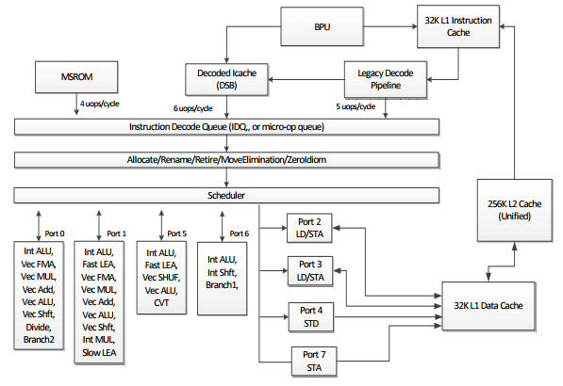

A block diagram of the SkyLake client core (Tech Report, 2017)

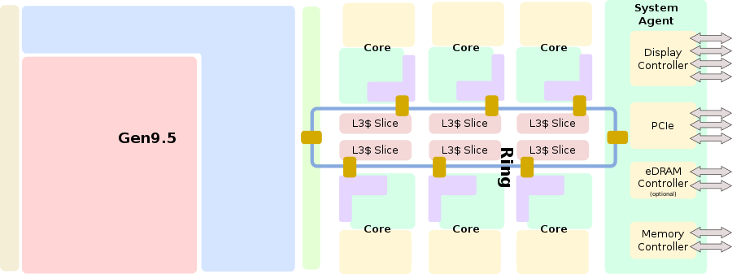

Entire SoC Overview (hexa)(Wikichip, 2017)

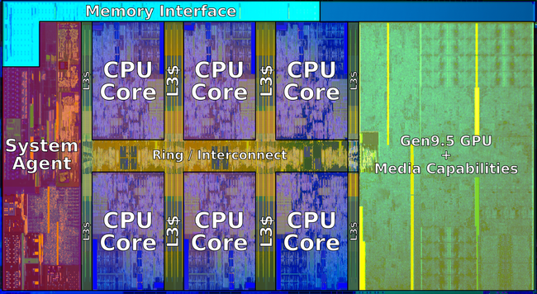

Hexa-core Die shot (Wikichip, 2017)

The AMD Ryzen 7 2700U is built on the AMD Zen architecture, the successor of both Excavator and Puma, manufactured on 14nm+ process. An entirely new design, built from scratch for optimal balance of performance and power capable of covering the entire computing spectrum from fanless notebooks to high-performance desktop computers (Wikichip, 2017) (Wikipedia, 2017).

The AMD Zen has a few changes from AMD’s previous architectures such as;

* L1 cache has been changed from write-through to write-back, allowing for lower latency and higher bandwidth
* Introduction of simultaneous multithreading (Hyper transport) to allow two threads per core.
* Core Complex (CCX) design, blocks of 4 cores with their associated caches. Processors with more than four cores consist of multiple CCXs connected by Infinity Fabric
* Four ALUs, two AGUS, and two floating-point units per core
* Each SMT core can dispatch up to 6 micro-ops per cycle (a combination of 6 integer micro-ops and 4 floating point micro-ops per cycle)

(Wikichip, 2017)

Below are 3 pictures, the first being the internal structure of each core within the Ryzen 7 2700U with its caches, ALUs, registers, and more. The second picture is the structure inside the CPU, a level above the core, showing the cores, cache, and controllers. The third picture is the die shot, the CPU structure in physical form.

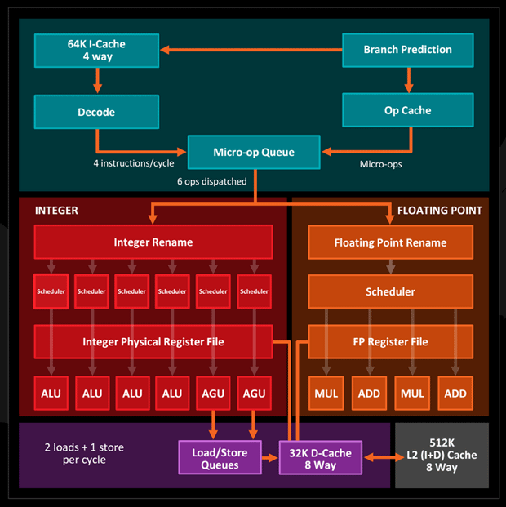

Entire SoC overview (WCCftech, 2017)

A block diagram of the Zen client core (WCCftech, 2017)

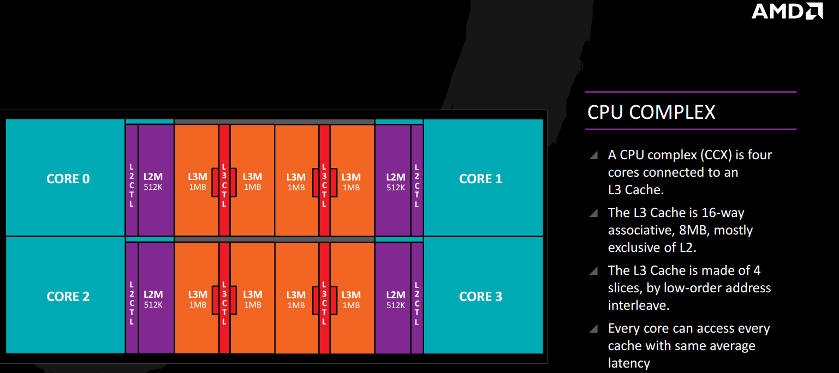

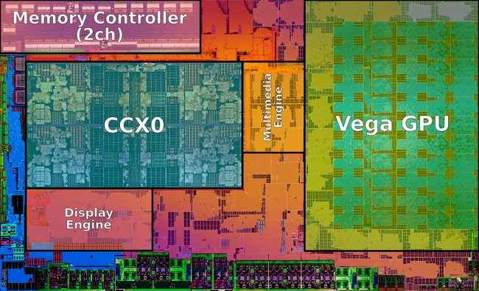

Ryzen die shot (Wikichip, 2017)

# **Conclusion**

Differentiating between the two is difficult, they both have their own reasons for why to pick that microprocessor. As for the I7 8700K, it possesses much higher performance of 2.92 times better and 2.53 times better when comparing price/performance, and so the I7 is a winner if only performance is the goal of the processor and nothing else matters.

However, the Ryzen uses significantly less power (3.825 times less) and generates a lot less heat, both of which is very important with the Ryzen being a notebook processor where power consumption and heat generation are key factures, compared to a desktop where they don’t matter in the way raw performance does.

As for architecture, the Ryzen 7 2700U is the first iteration of the Zen architecture on notebooks with room for improvements such as including ECC memory of which it supports, and utilising Zen’s 4 core block design for which the processor would have to be octa-core. All that said, it is AMDS first iteration compared to the I7 8700k which is an optimisation of Kaby lake, which in turn is an optimisation of Sky Lake, and so it isn’t surprising that the I7 8700K is better at the performance.

The biggest thing to take into consideration is Intel’s control on the processor market, for years Intel has been ahead with its processors raining supreme. However, AMD’s introduction of the Ryzen line of microprocessors shook up the market which forced Intel to release the Coffee Lake processors ahead of schedule. Even so, Ryzen is still popular and powerful and able to compete with Intel even with the release of Coffee Lake.

# **Section A – Algorithm**

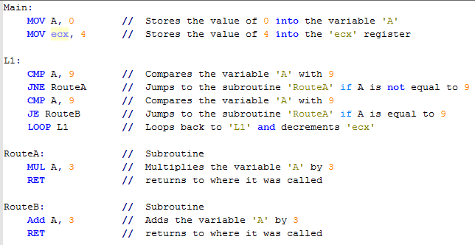

Algorithm in Assembly (Human made)

Above is an algorithm I designed in Assembly using the same Assembly that is used in the x86-64 instruction set, however, the above algorithm is created by a human rather than a computer and so is more efficient and bespoke for the intended use. Below is the algorithm designed in C++ and then converted to assembly (using a converter) using the same instruction set to see how the processor would convert a high-level language program to assembly.

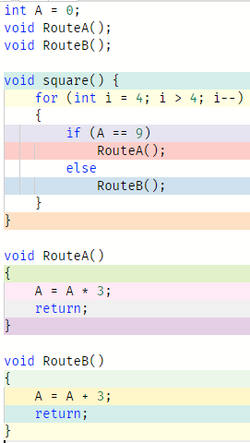

Algorithm in C++

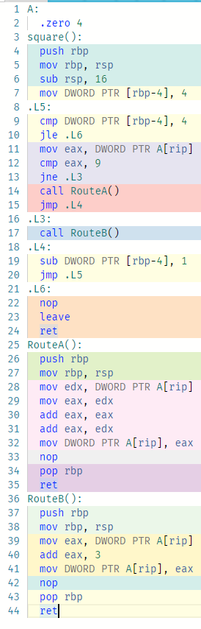

Algorithm in Assembly (converted by computer)

# **Section B – Parallel Processing**

Parallel computing can be provided by multicore (chip multiprocessor) or multiprocessor systems. With the latter, the multiple processors can be indistinct machines and operate either as one distributed system - symmetric multiprocessor (SMP), using a shared main memory, or non-shared memory systems where the workload of multiple processes/tasks is distributed around a cluster of machines, but the tasks themselves are distinct. Machines can also operate using a shared memory but with a cache-coherent Non-Uniform Memory Access (CC-NUMA) approach.

A program in execution is often referred as a process, while a thread is a subset (part) of the process. A process consists of multiple threads, a thread is the smallest part of the process that can execute concurrently with other parts(threads) of the process. A process has its own address space, while a thread uses the processes address space and share it with the other threads of that process (Beginners Book, 2015).

# **SMP (Symmetric Multiprocessing)**

SMP Block diagram (Wikipedia, 2017)

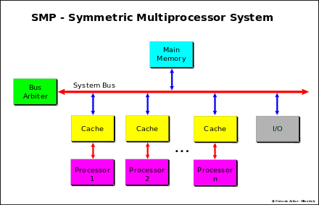Symmetric multiprocessing (SMP) involves a multiprocessor computer hardware and software architecture where two or more identical processors are connected to a single, shared main memory, have full access to all input and output devices, and are controlled by a single operating system instance that treats all processors equally, reserving none for special purposes (Wikipedia, 2017).

Using SMP has many advantages, including better performance (if work can be done parallelly); Availability, since all processors can perform the same functions, failure of a single processor does not halt the system; incremental growth, user can enhance performance by adding additional processors; and scaling, vendors can offer range of products based on number of processors (University of Washington, 2009).

# **Image result for computer cluster diagramCluster**

Cluster Diagram (Wikipedia, 2017)

A computer cluster is a set of loosely or tightly connected computers that work together so that, in many respects, they can be viewed as a single system. Computer clusters have each node set to perform the same task, controlled and scheduled by software. The components of a cluster are usually connected to each other through fast local area networks, with each node (computer used as a server) running its own instance of an operating system. Cluster has many advantages including absolute and incremental scalability, high availability, and superior price/performance (Wikipedia, 2017).

Both SMP and Cluster have their advantages, which one to pick differ depending on the intended use of the system.

SMP:

* Easier to manage and control
* Closer to single processor systems
  + Scheduling is main difference
  + Less physical space
  + Lower power consumption

Cluster:

* Superior incremental and absolute scalability
* Less cost
* Superior availability
  + Redundancy

(University of Washington, 2009)

# **CC – NUMA (Cache Coherence Non-Uniform Memory Access)**

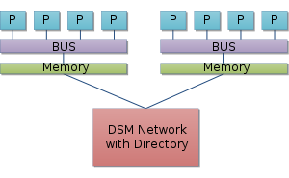Non-uniform memory access (NUMA) is a computer memory design used in multiprocessing, where the memory access time depends on the memory location relative to the processor. Under NUMA, a processor can access its own local memory faster than non-local memory (memory local to another processor or memory shared between processors) (Wikipedia, 2017).

With NUMA, maintaining cache coherence across shared memory has a significant overhead. Although simpler to design and build, non-cache-coherent NUMA systems become prohibitively complex to program in the standard von Neumann architecture programming model (Wikipedia, 2017).

NUMA diagram (Wikipedia, 2017)

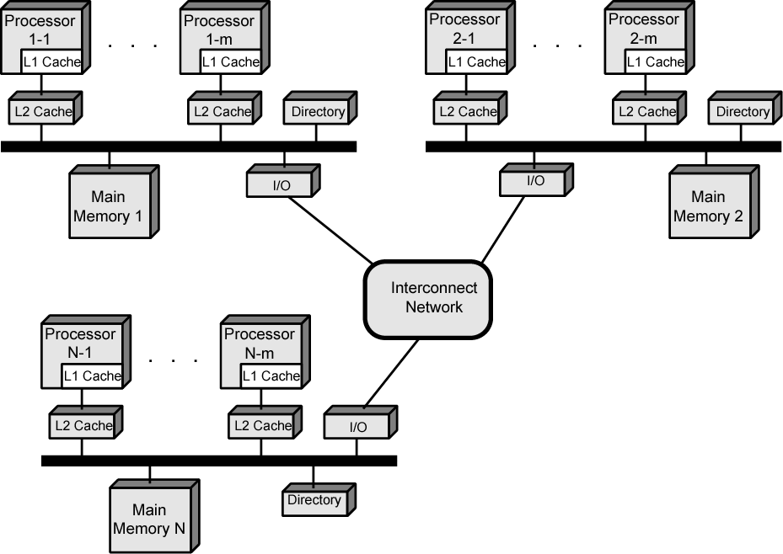CC-NUMA uses inter-processor communication between cache controllers to keep a consistent memory image when more than one cache stores the same memory location. For this reason, cc-NUMA may perform poorly when multiple processors attempt to access the same memory area in rapid succession. Support for NUMA in operating systems attempts to reduce the frequency of this kind of access by allocating processors and memory in NUMA-friendly ways and by avoiding scheduling and locking algorithms that make NUMA-unfriendly accesses necessary (Wikipedia, 2017).

CC-NUMA diagram (University of Washington, 2009)

The big advantage to NUMA is that it is a possibly more effective performance at higher levels of parallelism than one SMP. However, it also has many disadvantages including, that it’s not very supportive of software changes; performance can break down if too much access to remote memory (can be avoided by L1 and L2 cache design reducing all memory access); not transparent, page allocation, process allocation and load balance changes can be difficult; and finally, is that it doesn’t have any availability (redundancy) (University of Washington, 2009).

One can view NUMA as a tightly coupled form of cluster computing. The addition of virtual memory paging to a cluster architecture can allow the implementation of NUMA entirely in software. However, the inter-node latency of software-based NUMA remains several orders of magnitude greater (slower) than that of hardware-based NUMA (Wikipedia, 2017).

There as many reasons as to why one would use a CC-NUMA over SMP or Cluster even after its disadvantages. SMP has a practical limit to a number of processors, the bus traffic limits it to between 16 and 64 processors. In clusters, each node has its own memory, and so apps do not see the large global memory, plus coherence is maintained by software, not hardware resulting in performance drops. Whereas NUMA retains SMP design while giving large-scale multiprocessing (University of Washington, 2009).

Specifications of the systems (USC: University of Southern California, 2007)

|  |  |  |  |
| --- | --- | --- | --- |
| System Characteristic | SMP | Cluster | CC-NUMA |
| Number of Nodes | 10 or less | 100 or less | 10 -1000 |
| Node Complexity | Medium or coarse grain | Medium grain | Wide range |
| Internode Communication | Shared Memory | Message passing | Shared files, RPC, message passing |
| Job Scheduling | Single run queue | Multiple queues but coordinated | Independent multiple queues |
| SSI Support | Always | Desired | No |
| Node Os Copies and Type | One (monolithic) | N (homogeneous desired) | N (heterogeneous) |
| Address Space | Single | Multiple | Multiple |
| Internode Security | Unnecessary | Required if exposed | Required |
| Ownership | One organization | One or more organisations | Many organisations |
| Network Protocol | Nonstandard | Standard or Nonstandard | Standard |
| System Availability | Often low | Highly available or fault-tolerant | Medium |
| Performance Metrix | Turnaround time | Throughput and turnaround time | Response time |

The three types have different uses, each playing to their strengths and weaknesses. For SMP, it can be used for Time-sharing and server systems (without changes to applications). While most processors feature an SMP design, most programs aren't designed to be run off more than one processor but some programs are such as games and rendering software (Wikipedia, 2017). For cluster, it’s mainly used for multi-server systems or multi-computer supercomputers. For CC-NUMA, it can be used in multi-processor computers used for single server units or workstation computers.

# **References**

AMD, 2017. *AMD Ryzen 7 2700U.* [Online]   
Available at: https://www.amd.com/en/products/apu/amd-ryzen-7-2700u  
[Accessed 11 2017].

Beginners Book, 2015. *What is the Difference Between a Process and a Thread in Java.* [Online]   
Available at: https://beginnersbook.com/2015/01/what-is-the-difference-between-a-process-and-a-thread-in-java/  
[Accessed 11 2017].

Intel, 2017. *Intel Core i7-8700K Processor.* [Online]   
Available at: https://ark.intel.com/products/126684/Intel-Core-i7-8700K-Processor-12M-Cache-up-to-4_70-GHz  
[Accessed 11 2017].

SiSoftware, 2017. *Official Live Ranker - AMD Ryzen 7 2700U.* [Online]   
Available at: http://ranker.sisoftware.net/show_device.php?q=c9a598d994d0f0a2dba1c4aa8abd9daf98a898cdedbfdebadfb0defea8cdaacbebacdebfcfa7ceaddef89fa28fbe98ead7e7c1a895b3dbe6c0b885a3c6a39eae88fbc6fe&l=en  
[Accessed 11 2017].

Tech Report, 2017. *Intel Core i5 8250U CPU Reviewed.* [Online]   
Available at: https://techreport.com/review/32863/intel-core-i5-8250u-cpu-reviewed  
[Accessed 11 2017].

University of Washington, 2009. *Parallel Processing.* [Online]   
Available at: http://faculty.washington.edu/lcrum/TCSS372AF09/15_Parallel_Processing.ppt  
[Accessed 11 2017].

USC: University of Southern California, 2007. *SMP and ccNUMA Multiprocessor Systems.* [Online]   
Available at: http://gridsec.usc.edu/files/EE657/Hwang-EE657-Lectture5-SMPccNUMA-Sept14-2007.pdf  
[Accessed 11 2017].

WCCftech, 2016. *Amd Zen Architecture Details.* [Online]   
Available at: https://wccftech.com/amd-zen-architetcure-details/  
[Accessed 11 2017].

Wikichip, 2017. *2700U.* [Online]   
Available at: https://en.wikichip.org/wiki/amd/ryzen_7/2700u  
[Accessed 11 2017].

Wikichip, 2017. *Coffee Lake.* [Online]   
Available at: https://en.wikichip.org/wiki/intel/microarchitectures/coffee_lake  
[Accessed 11 2017].

Wikichip, 2017. *I7-8700K.* [Online]   
Available at: https://en.wikichip.org/wiki/intel/core_i7/i7-8700k  
[Accessed 11 2017].

Wikichip, 2017. *Zen.* [Online]   
Available at: https://en.wikichip.org/wiki/amd/microarchitectures/zen  
[Accessed 11 2017].

Wikipedia, 2017. *Coffee Lake.* [Online]   
Available at: https://en.wikipedia.org/wiki/Coffee_Lake  
[Accessed 11 2017].

Wikipedia, 2017. *Computer Cluster.* [Online]   
Available at: https://en.wikipedia.org/wiki/Computer_cluster  
[Accessed 11 2017].

Wikipedia, 2017. *Kaby Lake.* [Online]   
Available at: https://en.wikipedia.org/wiki/Kaby_Lake  
[Accessed 11 2017].

Wikipedia, 2017. *Non-uniform memory access.* [Online]   
Available at: https://en.wikipedia.org/wiki/Non-uniform_memory_access  
[Accessed 11 2017].

Wikipedia, 2017. *Official Live Ranker - Intel I7 8700K.* [Online]   
Available at: http://ranker.sisoftware.net/show_device.php?q=c9a598d1bfcbaec2e2a1cebcd9f990a78ab285b585cee88fb284bc9ae8d5e4c2ab96b0d8e5c3bb86a0c5a09dad8bf8c5f7&l=en  
[Accessed 11 2017].

Wikipedia, 2017. *Sky Lake (microarchitecture).* [Online]   
Available at: https://en.wikipedia.org/wiki/Skylake_(microarchitecture)  
[Accessed 11 2017].

Wikipedia, 2017. *Symmetric Multiprocessing.* [Online]   
Available at: https://en.wikipedia.org/wiki/Symmetric_multiprocessing  
[Accessed 11 2017].

Wikipedia, 2017. *x86.* [Online]   
Available at: https://en.wikipedia.org/wiki/X86  
[Accessed 11 2017].

Wikipedia, 2017. *x86-64.* [Online]   
Available at: https://en.wikipedia.org/wiki/X86-64  
[Accessed 11 2017].

Wikipedia, 2017. *Zen (microarchitecture).* [Online]   
Available at: https://en.wikipedia.org/wiki/Zen_(microarchitecture)  
[Accessed 11 2017].